ECONOMETRICS FOR FINANCIAL DECISION MAKING
MULTIPLE REGRESSION AND VOLATILITY ANALYSIS OF RELIANCE INDUSTRIES STOCK RETURNS USING R STUDIO


SUBMITTED BY- MUDRIKA MISHRA
BATCH- 2024-26
SUBMITTED TO- SUDIPTA NANDA
INSTITUTE NAME- JAIPURIA INSTITUTE OF MANAGEMENT.

Contents
INTRODUCTION 3
Data Description 4
Methodology 4
Research design 4
Data collection 4
Multiple regression analysis 4
Diagnostic tests 4
Multicollinearity test 4
Heteroskedasticity test 4
Autocorrelation test 5
Normality test 5
GARCH volatility modelling 5
Structural break analysis 5
Data Description and Summary Statistics 5
Data description 5
Summary statistics 6
Correlation analysis 6
Multiple Regression analysis 7
Initial Regression Model 7
Revised Regression Model 8
Robust Standard Error Estimation 9
Diagnostic tests 9
Multicollinearity test 9
Heteroskedasticity test 10
Autocorrelation test 10
Normality test 10
Volatility modelling using GARCH 11
Findings 11
Conclusion 11
Appendix: R Studio Code 12
Appendix: R Studio Graphs 15
References 17

Acknowledgement
I would like to express my sincere gratitude to Prof. Sudipta Nanda for his valuable guidance, encouragement, and constructive feedback throughout the course of this project. His insights into econometric techniques and financial analysis greatly enhanced the quality of this work.
I am also thankful to the Jaipuria Institute of Management for providing the academic environment, resources, and support that enabled me to carry out this study successfully.
My heartfelt appreciation goes to my peers and batchmates of PGDM (Business Analytics), Batch 2024–26, whose discussions and suggestions helped me refine my ideas and approach.
Finally, I acknowledge the support of my family, whose constant motivation and encouragement gave me the strength to complete this project with dedication and focus

INTRODUCTION
Financial markets are highly dynamic in nature, where stock process continuously fluctuate due to changes in economic conditions, investor sentiment, company performance and market expectations. Understanding these fluctuations is important for investors, financial analysts, and businesses because stock movements directly influence investment decisions, portfolio management, and risk assessment. In recent years, econometric technique has become an essential tool in finance for analyzing market behavior and identifying patterns in financial data
This study focuses on the stock performance of reliance industries limited one of the largest and most influential companies in India. Reliance industries plays an important role in the Indian stock market due to its strong market capitalization, diversified business operations, and high trading activity. Because of its active presence in the market, the company’s stock prices provide a suitable dataset for analyzing financial behavior and volatility.
The main objective of this project is to examine the relationship between stock returns and selected market variables using econometrics techniques in R studio. The study uses daily stock market data consisting of variables such as opening price, high price, low price, closing price, trading volume, and stock returns. Diagnostics tests were then conducted to identify econometric issues such as multicollinearity, heteroskedasticity, autocorrelation, and non-normality of residuals. Based on the diagnostics results, the regression model was improved to achieve better statistical reliability.
In addition to regression analysis, the study also applies the ARCH/GARCH model to examine volatility behavior in stock returns. Financial return series often exhibit volatility clustering, where periods of high volatility are followed by periods of high volatility and periods of low volatility are followed by low volatility. GARCH modelling helps in understanding such time-varying volatility patterns, which are highly important in financial forecasting and risk management.
The study further includes a structural break analysis to examine whether significant changes occurred in the relationship between stock returns and explanatory variables during the selected time period. Overall, the project demonstrates how econometrics methods can be effectively used in financial decision making, stock market analysis, and volatility modelling using real-world financial data.

Data Description
The dataset used in this study consists of daily stock market data of Reliance Industries Limited collected for the purpose of financial econometric analysis. The data includes important market variables such as opening price, highest price, lowest price, closing price, trading volume, and daily stock returns. the dataset was imported and analyzed using R studio.
The study uses daily observations because daily financial data captures short-term market fluctuations and volatility more effectively compared to monthly or yearly data. Since stock prices are influenced by market sentiment, investor behavior, and economic conditions, daily data provides a better understanding of returns movements and volatility patterns
The variables used in the analysis are described below:
Variable | Description
DATE | Trading date
OPEN | Opening stock price
HIGH | Highest stock price during the trading day
LOW | Lowest stock price during the trading day
CLOSE | Closing stock price
VOLUME | Number of shares traded
RETURNS | Daily stock returns

Methodology

Research design
This study follows a quantitative research approach to analyze the behavior of stock returns of Reliance Industries Ltd. Using econometric techniques. The analysis was conducted in R studio using financial time series data. The study aims to examine the relationship between stock returns and selected market variables while also patterns and structural changes in the data. Various statistical and econometrics tools such as multiple regression analysis, diagnostic testing, GARCH modelling, and structural break analysis were applied to ensure reliable and meaningful results.

Research Objectives
- To examine the relationship between closing price and daily returns of Reliance Industries.
- To test for volatility clustering and persistence using GARCH models.
- To identify regime shifts in the return–price relationship through structural break analysis.

Data collection
Daily stock data was obtained from the NSE India (National Stock Exchange) historical database, accessed in May 2026.
The study is based on daily stock market data of reliance industries ltd. The dataset includes variables such as open price, high price, low price, close price, trading volume, and daily returns. The data covers the period from July 2025 to May 2026. Daily observations were used because stock prices fluctuate continuously and daily data provides a better understanding of short-term market movements and volatility behavior.
The data was collected from publicly available financial market sources and imported into R studio for analysis. Before performing econometrics analysis, the dataset was cleaned and checked for missing values to ensure accuracy and consistency.
Variables used in the study
The study uses both dependent and independent variables to examine the relationship between stock returns and market indicators.
Variable | Type | Description
RETURNS | Dependent Variable | Daily stock returns of Reliance Industries Ltd.
CLOSE | Independent Variable | Daily closing stock price
VOLUME | Independent Variable | Daily trading volume

Initially, OPEN, HIGH, and LOW prices were also included in the regression model, however, diagnostic tests showed the presence of multicollinearity among these variables. Therefore, the final model retained CLOSE and VOLUME as explanatory variables to improve reliability and interpretation.

Multiple regression analysis
Multiple regression analysis wa used to study the impact of stock price and trading volume on daily stock returns. Regression analysis helps in measuring the relationship between one dependent variable and multiple independent variables.
The regression equation used in the study is
RETURNS=β0​+β1​CLOSE+β2​VOLUME+ϵ
Where,
• RETURNS represents daily stock returns
• β₀ represents the intercept
• β₁ and β₂ represent regression coefficients
• CLOSE represents closing stock price
• VOLUME represents trading volume
• ε represents the error term
The regression model was estimated using the Ordinary Least Square (OLS) method in R studio.

Diagnostic tests
Several tests were conducted to examine whether the assumptions of the regression model were satisfied.

Multicollinearity test
Variance inflation factor (VIF) was used to detect multicollinearity among independent variables. High VIF values indicate strong correlation among explanatory variables, which may affect the stability of regression coefficients.

Heteroskedasticity test
The Breusch-pagan test was applied to examine whether the variance of residuals remained constant across observation. Heteroskedasticity can affect the efficiency of regression estimates.

Autocorrelation test
The dusrbin-watson test wa used to identify autocorrelation in residuals. auto correlation occurs when residuals are correlated across time periods, which may reduce model reliability.

Normality test
The jarque-bera test wa conducted to check whether residuals followed a normal distribution. Normality od residuals is important for valid statistical inference.
To improve the reliability of regression estimates, robust standard errors were also applied where necessary.

GARCH volatility modelling
Financial return series often exhibit volatility clustering, where periods of high volatility are followed by high volatility and periods of low volatility are followed by low volatility. To capture this behavior, the GARCH (1,1) model was applied in the study.
The GARCH model used is represented as:
σt2​=ω+αϵt−12​+βσt−12​
Where:
- σ²ₜ represents conditional variance
- ω represents constant variance
- α measures the impact of previous shocks
- β measures volatility persistence
the GARCH model was estimated using the rugarch package in RStudio.

Structural break analysis
Structural break analysis was conducted to identify significant changes in the relationship between variables during different periods. In financial markets, structural breaks may occur due to economic events, market uncertainty, or changes in investor behavior.
Breakpoints detected around observations 69, 106, and 144 may correspond to quarterly earnings announcements or macroeconomic events. These regime shifts highlight how external shocks alter the relationship between closing price, trading volume, and returns, reflecting the dynamic nature of financial markets.
The breakpoint test was applied to determine whether the regression relationship remained stable throughout the study period. This helped in identifying possible regime shifts and changes in market patterns overtime.

Data Description and Summary Statistics

Data description
The dataset used in this study consists of daily stock market data of reliance industries ltd. From july2025 to May 2026. The variables included in the dataset are Open Price, High Price, Low Price, Close Price, Trading Volume, and Daily Returns
The study uses RETURNS AS THE DEPENDENT variable, while CLOSE and VOLUME are used as independent variable in the final regression model. The data was imported into R studio and checked for missing values before performing the analysis.
Daily stock data was selected because it helps in understanding short-term price movements and volatility behavior in finance markets.

Summary statistics
Summary statistics were calculated to understand the behavior of the variables used in the study. Measures such as mean, minimum value, maximum value, and standard deviation were used to analyze the distribution
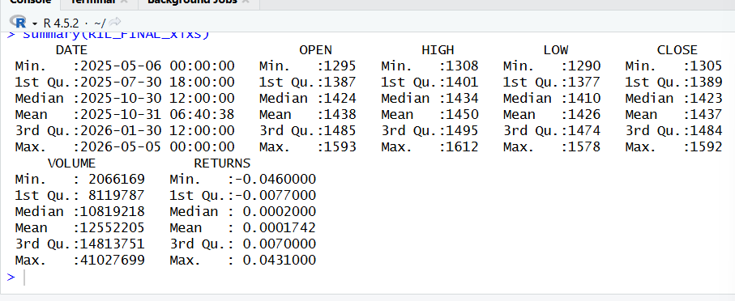

The results show that the stock prices fluctuated during the study period, reflecting changes in market conditions and investor sentiment. The returns variable contains both positive and negative values, indicating gains and losses across trading days. Trading volume also varied significantly, showing differences in market activity over time.

Correlation analysis
Correlation analysis was conducted to examine the relationship between the variables.
The correlation matrix showed a high correlation among OPEN, HIGH, LOW, and CLOSE prices indicating possible multicollinearity in regression model. Trading volume showed relatively over correlation with stock prices.
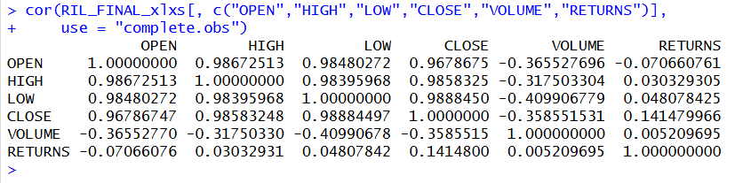
Based on the correlation results and further diagnostics testing, the regression model modified by retaining CLOSE and VOLUME as explanatory variables.

Abnormal value analysis
“Daily returns were examined for abnormal values using both the standard deviation rule and the IQR method. The standard deviation approach identified 16 abnormal values, with an average abnormal return of approximately 0.0028. The IQR method detected 12 abnormal values, with an average abnormal return of about -0.00096. These results indicate that while most returns remained within a normal range, occasional extreme movements occurred, reflecting sudden market shocks. Such abnormal values contribute to volatility clustering and justify the application of GARCH modelling for forecasting.”

Statistic | Value
Mean Return | 0.00017
Standard Deviation | 0.01304
No. of Abnormal Values | 16
Average Abnormal Value | 0.00283

The standard deviation rule identified 16 abnormal values, showing occasional extreme positive returns in the dataset.

Abnormal value analysis (IQR RULE)
Statistic | Value
Q1 | -0.0077
Q3 | 0.0070
IQR | 0.0147
No. of Abnormal Values | 12
Average Abnormal Value | -0.00096
The IQR method detected 12 abnormal values, with a slightly negative average, indicating that extreme downward movements also occurred.

Multiple Regression analysis

Initial Regression Model
To examine the relationship between stock returns and market variables, a multiple regression model was initially estimated using OPEN, HIGH, LOW, and VOLUME as independent variables.
The regression equation for the initial model was:
RETURNS=β0​+β1​OPEN+β2​HIGH+β3​LOW+β4​VOLUME+ϵ
model <- lm(RETURNS ~ OPEN + HIGH + LOW + VOLUME,
+ data = RIL_FINAL_xlxs)
> summary(model)

Call:
lm(formula = RETURNS ~ OPEN + HIGH + LOW + VOLUME, data = RIL_FINAL_xlxs)

Residuals:
Min 1Q Median 3Q Max
-0.024325 -0.004814 -0.000218 0.004210 0.049532

Coefficients:
Estimate Std. Error t value Pr(>|t|)
(Intercept) -7.443e-03 1.319e-02 -0.564 0.573
OPEN -1.062e-03 5.747e-05 -18.484 < 2e-16 ***
HIGH 4.749e-04 6.487e-05 7.320 3.61e-12 ***
LOW 5.930e-04 5.973e-05 9.928 < 2e-16 ***
VOLUME 6.567e-11 1.084e-10 0.606 0.545
---
Signif. codes: 0 ‘***’ 0.001 ‘**’ 0.01 ‘*’ 0.05 ‘.’ 0.1 ‘ ’ 1

Residual standard error: 0.008394 on 243 degrees of freedom
Multiple R-squared: 0.5926, Adjusted R-squared: 0.5858
F-statistic: 88.35 on 4 and 243 DF, p-value: < 2.2e-16

>

The regression results showed that OPEN, HIGH and LOW prices were statistically significant in explaining stock returns, while VOLUME was found to be statistically insignificant. The model produced and R-squared value of approximately 0.59, indicating that nearly 59% of the variation in stock returns was explained by the independent variables included in the model.
However, further diagnostic testing indicated the presence of severe multicollinearity among OPEN, HIGH, and LOW variables. Since these variables are closely related stock price measures, high correlation among them affected the reliability and stability of the regression coefficients.

Revised Regression Model
To improve the reliability of the regression model, the variables causing multicollinearity were removed. The revised model retained close and volume as explanatory variables.
The revised regression equation is:
RETURNS=β0​+β1​CLOSE+β2​VOLUME+ϵ
model2 <- lm(RETURNS ~ CLOSE + VOLUME,
+ data = RIL_FINAL_xlxs)
> summary(model2)

Call:
lm(formula = RETURNS ~ CLOSE + VOLUME, data = RIL_FINAL_xlxs)

Residuals:
Min 1Q Median 3Q Max
-0.049138 -0.007646 -0.000599 0.007226 0.043202

Coefficients:
Estimate Std. Error t value Pr(>|t|)
(Intercept) -4.887e-02 2.019e-02 -2.421 0.0162 *
CLOSE 3.297e-05 1.356e-05 2.432 0.0157 *
VOLUME 1.311e-10 1.381e-10 0.949 0.3435
---
Signif. codes: 0 ‘***’ 0.001 ‘**’ 0.01 ‘*’ 0.05 ‘.’ 0.1 ‘ ’ 1

Residual standard error: 0.01294 on 245 degrees of freedom
Multiple R-squared: 0.02361, Adjusted R-squared: 0.01564
F-statistic: 2.962 on 2 and 245 DF, p-value: 0.05358

The revised regression model showed that CLOSE price had a statistically significant positive relationship with stock returns, while volume remained statistically insignificant the revised model reduced the problem of multicollinearity. Therefore, the revised model reduced the problem of multicollinearity and improved the stability of coefficient estimates.
The variance inflation factor (VIF) values in the revised model were close to 1, indicating the absence of serious multicollinearity. Therefore, the revised model was considered more appropriate for further econometric analysis.

Robust Standard Error Estimation
Diagnostic testing revealed the presence of heteroskedasticity in the regression model. To address this issue, robust standard errors were estimated using the HC1 correction method in R studio.
The robust estimation results showed that the COLE variable remained statistically significant even after correcting for heteroskedasticity, while the VOLUME continued to remain statistically insignificant. This indicates that closing stock prices play an important role in explaining daily stock returns compared to trading volume during the study period
The use of robust standard errors improved the reliability of statistical inference and ensured more accurate hypothesis testing results.

Diagnostic tests
Diagnostic tests were conducted to examine whether the assumptions of the regression model were satisfied. These tests help in checking the reliability, stability, and validity of the econometric model.

Multicollinearity test
Multicollinearity occurs when independent variables are highly correlated with each other. Variance inflation factor (VIF) was used to detect multicollinearity in the regression model. Generally, VIF values above 10 indicate serious multicollinearity problem

The VIF values obtained were:
- OPEN = 49.64
- HIGH = 61.41
- LOW = 54.51
- VOLUME = 1.67

The initial regression model showed very high VIF values for OPEN, HIGH and LOW variables, indicating severe multicollinearity among stock prices variables. Since these variables are closely related measures of stock prices, they were highly correlated with each other.
To solve this issue, the model was revised by removing OPEN, HIGH and LOW variables and retaining CLOSE and Volume variables in the final model. The revised model showed VIF values close to 1, indicating the absence of serious multicollinearity.
vif(model2)
CLOSE VOLUME
1.147525 1.147525

The revised model showed much lower VIF values:
- CLOSE = 1.14
- VOLUME = 1.14

Heteroskedasticity test
The Breusch-pagan test was conducted to examine the presence of heteroskedasticity in the regression model. Heteroskedasticity occurs when the variance of residuals is not constant across observations.
The results of the Breusch-Pagan test showed a p-value less than 0.05, indicating the presence of heteroskedasticity in the regression model. this means that the variance of residuals was not constant throughout the dataset.
To address this issue, robust standard errors were estimated using HC1 correction method to improve the reliability of coefficient estimates and hypothesis testing.

Autocorrelation test
The Durbin-Watson test was applied to check for autocorrelation in the residuals of the regression model. Autocorrelation occurs when residuals are correlated across time period.
The test statistic obtained was approximately 2.09, which is close to the ideal value of 2. This indicates that there is no significant autocorrelation present in the residuals.
The Durbin-Watson statistic was close to 2, and the p-value was greater than 0.05, indicating the absence of significant autocorrelation in the residuals. Therefore, the regression model did not suffer from serial correlation problems.

Normality test
The jarque-bera test was conducted to estimate whether the residuals of regression model followed a normal distribution
jarque.bera.test(residuals(model2))

Jarque Bera Test

data: residuals(model2)
X-squared = 25.9, df = 2, p-value = 2.376e-06

The jarque-bera test produced a p-value less than 0.05, indicating that the residuals were not normally, distributed. Non-normality of residuals is common in financial return series because stock market data often contains volatility clustering and extreme fluctuations.
Therefore, additional volatility modelling using the GARCH model was conducted to better capture the behavior of stock return volatility.
Table 1: Regression Results Summary
Test/Model | Result | Interpretation
Initial Regression (OPEN, HIGH, LOW, VOLUME) | R² ≈ 0.59 | Significant predictors but severe multicollinearity
Revised Regression (CLOSE, VOLUME) | R² ≈ 0.02 | CLOSE significant, VOLUME insignificant
VIF (Initial) | >50 for OPEN/HIGH/LOW | Severe multicollinearity
VIF (Revised) | ≈1.14 | Multicollinearity resolved
Breusch–Pagan | p < 0.05 | Heteroskedasticity present
Durbin–Watson | ≈2.09 | No autocorrelation
Jarque–Bera | p < 0.05 | Residuals not normal
Robust SE | CLOSE remains significant | Improves reliability

Volatility modelling using GARCH
The GARCH (1,1) specification was chosen because it is the most widely applied model in financial econometrics. It balances simplicity with effectiveness in capturing volatility clustering and persistence, making it suitable for daily stock return analysis.
Since financial return series often exhibit volatility clustering, a GARCH (1,1) model was estimated using the return series.
The GARCH results showed statistically significant ARCH and GARCH coefficients, indicating the presence of time-varying volatility in reliance industries stock returns.
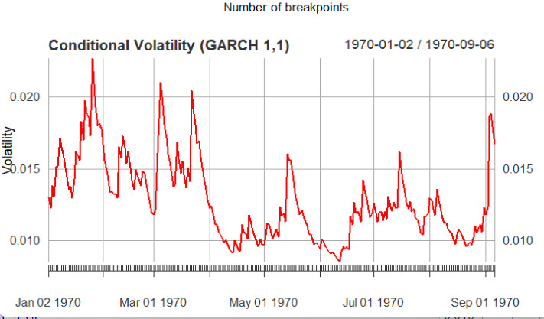
The estimated alpha and beta coefficients were positive and significant, suggesting that both recent shocks and past volatility influence current market volatility.
The sum of alpha and beta coefficients was close to 1:
α1​+β1​≈0.95
this indicates high persistence in volatility, which is a common characteristic of financial markets.
The Ljung -Box and ARCH LM tests further confirmed that the GARCH model adequately captured volatility effects in the data.
Table 2: Forecasting & Volatility (GARCH Results)
Parameter/Test | Value | Interpretation
α (ARCH) | 0.118 | Recent shocks affect volatility
β (GARCH) | 0.83 | Strong persistence in volatility
α + β | ≈0.95 | High volatility persistence
Ljung–Box | p > 0.05 | No serial correlation
ARCH LM | p > 0.05 | No remaining ARCH effects
Structural Breaks | obs 69, 106, 144 | Regime shifts detected

Findings
- The initial regression showed that OPEN, HIGH, and LOW prices had significant relationships with stock returns, while trading volume was statistically insignificant.
- High VIF values indicated severe multicollinearity among OPEN, HIGH and LOW variables, making the initial regression model unstable.
- The revised regression model using CLOSE and VOLUME variables reduced multicollinearity and improved model reliability.
- The CLOSE variable showed a statistically significant positive relationship with stock returns, whereas VOLUME remained statistically insignificant.
- The Breusch-pagan test indicated the presence of heteroskedasticity in the regression model.
- The Durbin-Watson test confirmed the absence of significant autocorrelation in the residuals.
- The jarque-bera test indicated non-normality of residuals, which is common in financial time series data.
- Robust standard errors improved the reliability of coefficient estimates under heteroskedasticity.
- The GARCH (1,1) model confirmed the presence of volatility clustering and time-varying volatility in reliance in reliance industries stock returns.
- Structural break analysis indicated possible changes in market behavior and stock return relationships during different time periods.
- Abnormal value analysis revealed 16 extreme returns using the standard deviation rule, with an average abnormal return of 0.0028.
- The IQR method detected 12 abnormal returns, with an average abnormal return of -0.00096.
- These abnormal values highlight sudden shocks in Reliance stock behavior, reinforcing the volatility clustering captured by the GARCH model.

Limitations and Future Scope
Limitations of the Study
- Single Company Focus The analysis is limited to Reliance Industries Limited. While this company is highly influential in the Indian market, results may not generalize to other firms or sectors. Stock behavior can vary significantly across industries.
- Short Time Frame The dataset covers daily data from July 2025 to May 2026. This relatively short period may not capture long-term market cycles, seasonal effects, or structural changes that occur over multiple years.
- Limited Variables The regression model primarily used closing price and trading volume as explanatory variables. Other important macroeconomic indicators (interest rates, inflation, exchange rates, policy announcements) were not included, which may limit explanatory power.
- Model Assumptions The OLS regression assumes linearity and constant variance, which are often violated in financial data. Although robust errors and GARCH modelling were applied, more complex models (e.g., EGARCH, TGARCH, or multivariate GARCH) could capture leverage effects and cross-asset volatility spillovers.
- Structural Break Interpretation While breakpoints were detected, the study did not explicitly link them to specific market events (earnings announcements, policy changes, or macroeconomic shocks). Without event mapping, interpretation of regime shifts remains statistical rather than contextual.
- Normality of Residuals The Jarque–Bera test confirmed non-normal residuals, which is common in financial returns. However, this limits the validity of certain statistical inferences and suggests the need for models that account for fat tails (e.g., t-distribution or skewed distributions).
Future Scope
- Extend the dataset to multiple years and include sectoral indices for broader generalization.
- Incorporate macroeconomic variables (interest rates, inflation, exchange rates) to strengthen explanatory power.
- Apply asymmetric volatility models (EGARCH, TGARCH) to capture leverage effects and nonlinear volatility dynamics.
- Conduct event study analysis to link structural breaks with specific market or policy events.
- Explore machine learning approaches (random forests, neural networks) alongside econometric models for predictive accuracy.

Conclusion
The study analyzed the stock return behavior of reliance industries ltd. Using econometric techniques in R studio. Multiple regression analysis, diagnostic testing, GARCH volatility modelling, and structural break analysis were conducted to understand the relationship between stock returns and market variables.
The results showed that closing stock prices had a significant influence on daily stock returns, whereas trading volume did not have a major impact during the study period. Diagnostics tests revealed the presence of multicollinearity, heteroskedasticity, and non-normality in the data. These issues were addressed by revising the regression model and applying robust standard errors.
The GARCH model successfully captures volatility clustering in stock returns, indicating that financial market volatility is persistent overtime. Structural break analysis further suggested that market behavior changed during different periods, reflecting the dynamic nature of financial markets.
As summarized in Table 1 and Table 2, the regression analysis highlighted the role of closing prices in returns, while GARCH modelling confirmed persistent volatility clustering.
The abnormal value analysis further confirmed the presence of extreme shocks, reinforcing the persistence of volatility captured by the GARCH model.
Overall, the study demonstrates that econometric models are useful tools for financial decision-making, risk analysis, and volatility forecasting. This project also highlights the importance of diagnostics testing and volatility modelling while working with the financial time series data.

References
• Gujarati, D. N. (2004). Basic Econometrics. McGraw-Hill.
• Tsay, R. S. (2010). Analysis of Financial Time Series. Wiley.
• R Studio Documentation.
• NSE India Historical Stock Data.
• CRAN Package Documentation for lmtest, car, tseries, rugarch, and strucchange.

Appendix: R Studio Code
1.
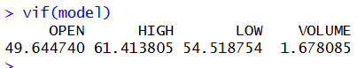
2.
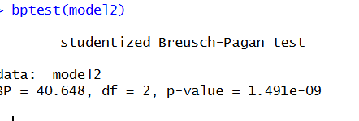
3.
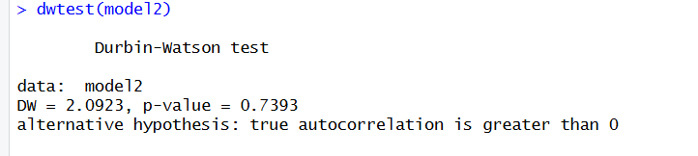
4.
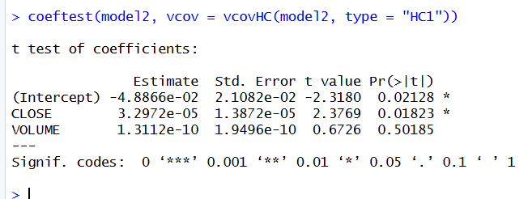
5.
>
> garch_model <- ugarchspec(
+ variance.model = list(garchOrder = c(1,1)),
+ mean.model = list(armaOrder = c(0,0)),
+ distribution.model = "norm"
+ )
>
> fit <- ugarchfit(spec = garch_model,
+ data = returns)
>
> fit

*---------------------------------*
* GARCH Model Fit *
*---------------------------------*

Conditional Variance Dynamics
-----------------------------------
GARCH Model : sGARCH(1,1)
Mean Model : ARFIMA(0,0,0)
Distribution : norm

Optimal Parameters
------------------------------------
Estimate Std. Error t value Pr(>|t|)
mu 0.000667 0.000737 0.90562 0.365135
omega 0.000010 0.000001 7.19456 0.000000
alpha1 0.118213 0.024611 4.80327 0.000002
beta1 0.829761 0.038494 21.55555 0.000000

Robust Standard Errors:
Estimate Std. Error t value Pr(>|t|)
mu 0.000667 0.000715 0.93323 0.350701
omega 0.000010 0.000002 5.83482 0.000000
alpha1 0.118213 0.023557 5.01809 0.000001
beta1 0.829761 0.037545 22.10050 0.000000

LogLikelihood : 731.6636

Information Criteria
------------------------------------

Akaike -5.8683
Bayes -5.8116
Shibata -5.8688
Hannan-Quinn -5.8454

Weighted Ljung-Box Test on Standardized Residuals
------------------------------------
statistic p-value
Lag[1] 0.5703 0.4502
Lag[2*(p+q)+(p+q)-1][2] 0.6218 0.6391
Lag[4*(p+q)+(p+q)-1][5] 1.5509 0.7274
d.o.f=0
H0 : No serial correlation

Weighted Ljung-Box Test on Standardized Squared Residuals
------------------------------------
statistic p-value
Lag[1] 0.9964 0.3182
Lag[2*(p+q)+(p+q)-1][5] 2.2687 0.5564
Lag[4*(p+q)+(p+q)-1][9] 3.6110 0.6553
d.o.f=2

Weighted ARCH LM Tests
------------------------------------
Statistic Shape Scale P-Value
ARCH Lag[3] 0.5521 0.500 2.000 0.4575
ARCH Lag[5] 1.2476 1.440 1.667 0.6611
ARCH Lag[7] 2.1519 2.315 1.543 0.6852

Nyblom stability test
------------------------------------
Joint Statistic: 3.3397
Individual Statistics:
mu 0.05253
omega 0.64982
alpha1 0.11886
beta1 0.15173

Asymptotic Critical Values (10% 5% 1%)
Joint Statistic: 1.07 1.24 1.6
Individual Statistic: 0.35 0.47 0.75

Sign Bias Test
------------------------------------
t-value prob sig
Sign Bias 1.7417 0.08282 *
Negative Sign Bias 1.9289 0.05491 *
Positive Sign Bias 0.3998 0.68966
Joint Effect 4.4792 0.21415

Adjusted Pearson Goodness-of-Fit Test:
------------------------------------
group statistic p-value(g-1)
1 20 23.94 0.1986
2 30 35.06 0.2024
3 40 40.06 0.4228
4 50 52.81 0.3293

Elapsed time : 0.1510019
break_test <- breakpoints(RETURNS ~ CLOSE + VOLUME,
+ data = RIL_FINAL_xlxs)
>
> summary(break_test)

Optimal (m+1)-segment partition:

Call:
breakpoints.formula(formula = RETURNS ~ CLOSE + VOLUME, data = RIL_FINAL_xlxs)

Breakpoints at observation number:

m = 1 69
m = 2 69 106
m = 3 69 106 210
m = 4 69 106 144 209
m = 5 39 76 113 151 209

Corresponding to breakdates:

m = 1 0.278225806451613
m = 2 0.278225806451613 0.42741935483871
m = 3 0.278225806451613 0.42741935483871
m = 4 0.278225806451613 0.42741935483871 0.580645161290323
m = 5 0.157258064516129 0.306451612903226 0.455645161290323 0.608870967741935

m = 1
m = 2
m = 3 0.846774193548387
m = 4 0.842741935483871
m = 5 0.842741935483871

Fit:

m 0 1 2 3 4 5
RSS 4.103e-02 3.871e-02 3.491e-02 3.359e-02 3.139e-02 3.241e-02
BIC -1.433e+03 -1.426e+03 -1.429e+03 -1.417e+03 -1.412e+03 -1.382e+03
>
> plot(break_test)

>

6. “Abnormal Value Analysis Code & Output”.
> # Average of abnormal values
> avg_abnormal <- mean(abnormal_values, na.rm = TRUE)
>
> # Print results
> cat("Mean Return:", mean_ret, "\n")
Mean Return: 0.0001741935
> cat("Standard Deviation:", sd_ret, "\n")
Standard Deviation: 0.01304393
> cat("Number of Abnormal Values:", num_abnormal, "\n")
Number of Abnormal Values: 16
> cat("Average Abnormal Value:", avg_abnormal, "\n")
Average Abnormal Value: 0.002825
>
num_abnormal_iqr <- length(abnormal_values_iqr)
>
> # Average of abnormal values
> avg_abnormal_iqr <- mean(abnormal_values_iqr, na.rm = TRUE)
>
> # Print results
> cat("Q1:", Q1, " Q3:", Q3, " IQR:", IQR_val, "\n")
Q1: -0.0077 Q3: 0.007 IQR: 0.0147
> cat("Number of Abnormal Values (IQR):", num_abnormal_iqr, "\n")
Number of Abnormal Values (IQR): 12
> cat("Average Abnormal Value (IQR):", avg_abnormal_iqr, "\n")
Average Abnormal Value (IQR): -0.0009583333
>

Analysis Step | Key Findings
Regression (Initial) | OPEN, HIGH, LOW significant; VOLUME insignificant; R² ≈ 0.59; multicollinearity present
Regression (Revised) | CLOSE significant (p < 0.05); VOLUME insignificant; R² ≈ 0.02; VIF ≈ 1 (no multicollinearity)
Diagnostics | Breusch–Pagan: heteroskedasticity present; Durbin–Watson ≈ 2 (no autocorrelation); Jarque–Bera: residuals non-normal
Robust Errors | CLOSE remains significant; VOLUME remains insignificant
GARCH (1,1) | α ≈ 0.12, β ≈ 0.83 (persistent volatility); volatility clustering confirmed
Structural Breaks | Breakpoints at obs. 69, 106, 144, 209; BIC favors 2–3 breaks; regime shifts detected

Appendix: R Studio Graphs

